Issue & Referrals – Screen Shots
Handout #1

ISSUES – Part 1
Teacher Handout

Start:  Start in Chrome, go to your EPS  Managed Bookmarks, and click on Teacher Access Center 4.0 | 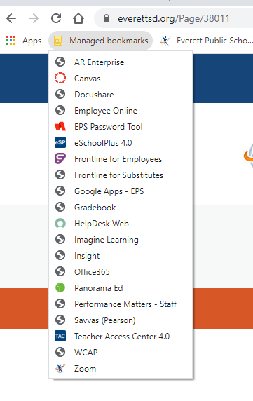
Next:  Open Tac and Select Interventions | 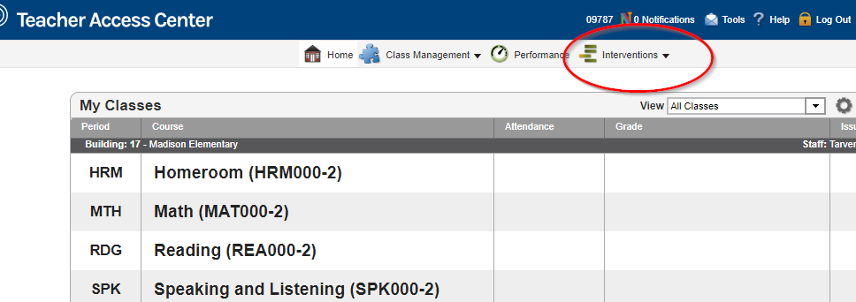
Next:  Open dropdown window and select classroom issues | 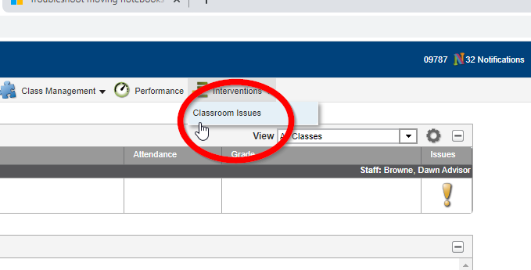
Next:  Classroom Issue Window opens | 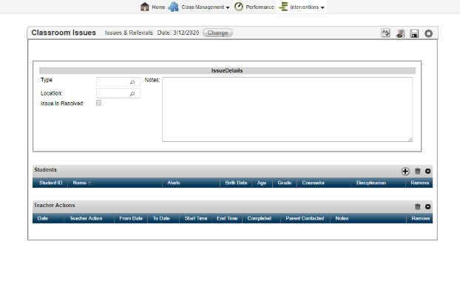
Next:  Select Type | 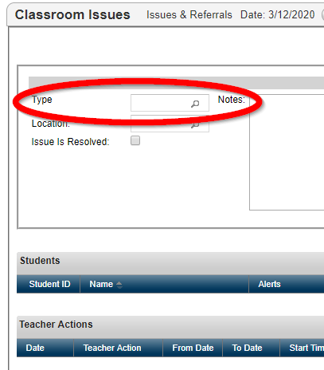
Next:  Drop down codes appear | 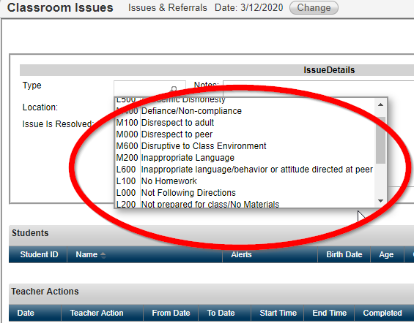
Next:  Select Code | 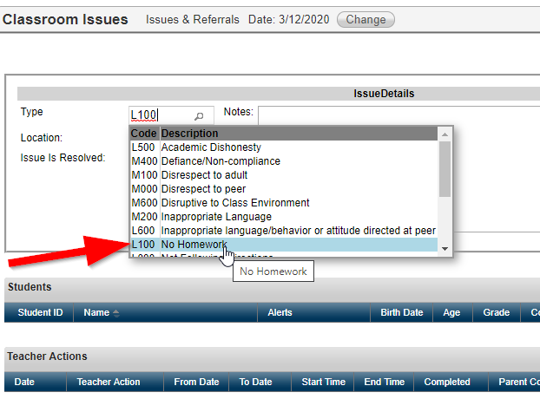
Next:  Select location | 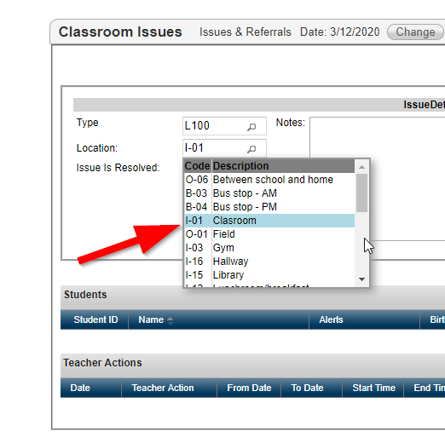
Next:  Enter description with Function language | 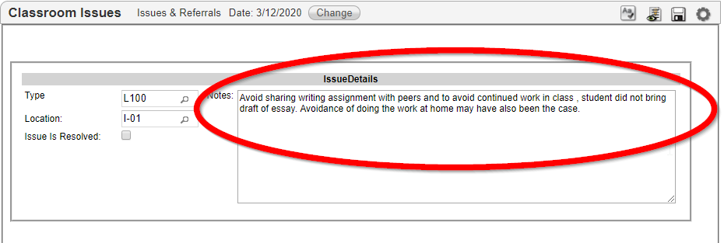
Next:  Use PLUS symbol to dropdown list of students | 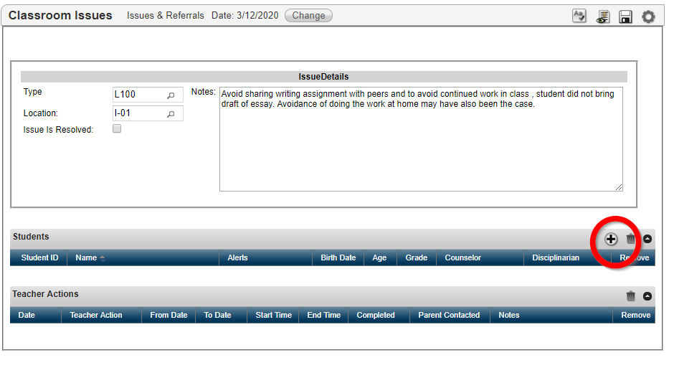
Next:  Select Students | 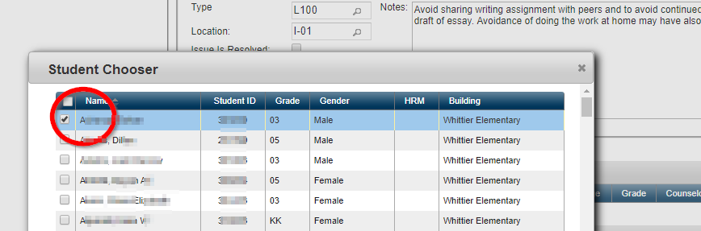
Next:  Use PLUS Symbol under Teacher action to add intervention | 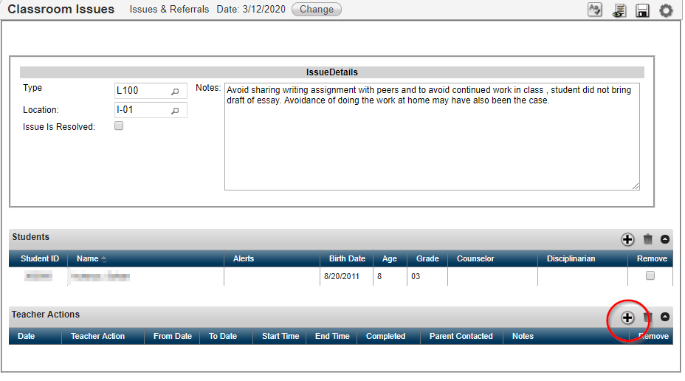
Next:  Use Drop down to add action | 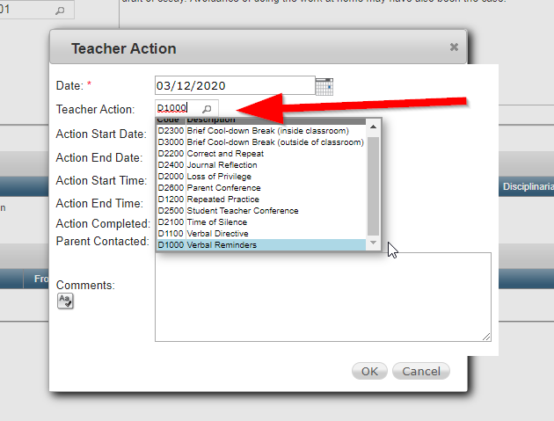
Next:  Parent contact boxes and intervention outcomes.  Be sure to hit save. | 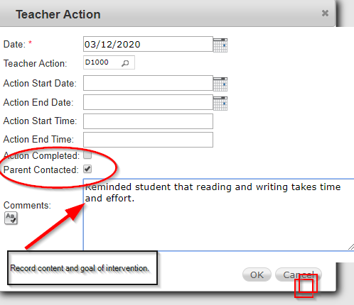
Next:  Referring for support | 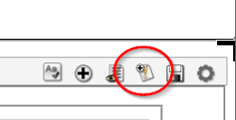  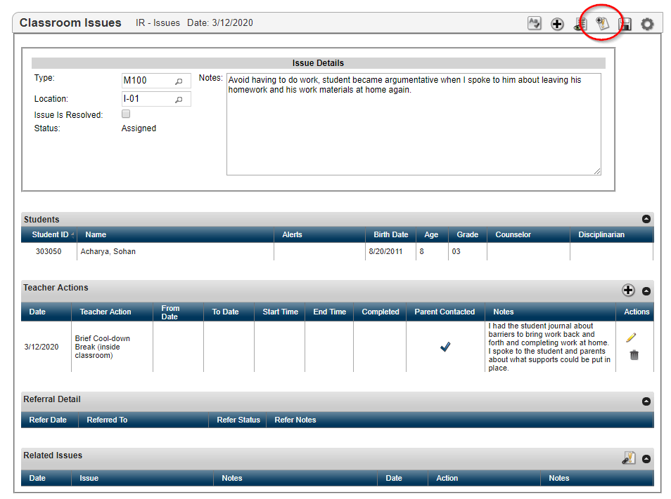
Next:  adding notes to referral | 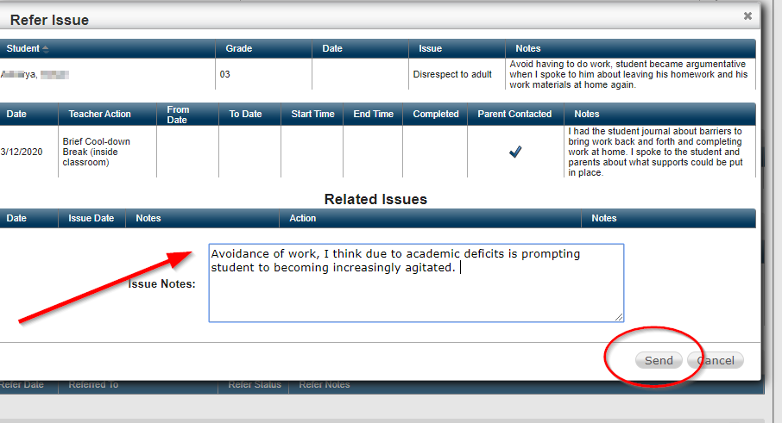
Next:  Incident List with referral | 